Demand Forecasting and Recommendations Assignment

- Anish Dhondi

1. SYSTEM DESIGN: BUSINESS KPIS

For our e-commerce platform's ML system to be successful, we need to track specific Key Performance Indicators (KPIs) that directly measure business impact and system performance.

1.1 RECOMMENDATION SYSTEM KPIS

Click-Through Rate (CTR)
• Measures: User clicks on recommended products
• Target: >5% improvement
• Impact: Direct measure of recommendation relevance
• Formula: (Clicks ÷ Recommendations Shown) × 100

Conversion Rate
• Measures: Recommendation clicks leading to purchases
• Target: >3% improvement
• Impact: Direct revenue correlation
• Formula: (Purchases ÷ Clicks) × 100

Customer Retention Rate
• Measures: Customers returning within 30-90 days
• Target: 10-15% improvement
• Impact: Addresses core problem of customer churn
• Formula: (Returning Customers ÷ Total Customers) × 100

Revenue Per User (RPU)
• Measures: Revenue generated per user from recommendations
• Target: 15-20% increase
• Impact: Financial ROI of personalization

Engagement Metrics:
• Session Duration: Average time users spend on platform
• Pages Per Session: Number of product pages viewed per session
• Add-to-Cart Rate: Percentage of recommended products added to cart
• Cross-sell/Up-sell Rate: Success rate of recommending complementary products

1.2 DEMAND FORECASTING KPIS

Mean Absolute Percentage Error (MAPE)
• Measures: Prediction accuracy vs actual demand
• Target: <15% seasonal, <10% regular products
• Impact: Optimizes inventory management
• Formula: |Actual - Predicted| ÷ Actual × 100

Stockout Rate
• Measures: Time products are out of stock
• Target: <5% normal periods, <10% peak seasons
• Impact: Prevents lost sales and customer dissatisfaction

Inventory Turnover
• Measures: Speed of inventory replacement
• Target: 12-15 times/year for fashion
• Impact: Reduces costs and prevents obsolescence

Operational Metrics:
• Demand Prediction Lead Time: Time between prediction and actual demand
• Forecast Bias: Tendency to over-forecast or under-forecast
• Safety Stock Optimization: Reduction in excess inventory while maintaining service levels

1.3 PLATFORM PERFORMANCE KPIS

System Uptime
• Target: 99.9% during peak events
• Impact: Prevents revenue loss during critical periods

API Response Time
• Target: <200ms recommendations, <500ms search
• Impact: Maintains user experience and prevents abandonment

Scalability Metrics:
• Peak traffic handling capacity
• Auto-scaling efficiency
• Resource utilization optimization

Model Performance
• Model freshness: Weekly updates minimum
• Drift detection: Automated monitoring of performance degradation
• A/B testing: Track improvement rate of new model versions

2. MLOPS ADVANTAGES
MLOps provides critical advantages over basic ML models for e-commerce platforms:
2.1 SCALABILITY AND AUTOMATION

Traditional Model Issues:
• Manual training and deployment
• Limited data processing capacity
• Constant human intervention required
• Poor scalability with business growth

MLOps Solutions:
• End-to-end automation of ML pipeline
• Real-time processing of millions of interactions
• Auto-scaling during peak traffic (Black Friday)
• Continuous learning from new data

2.2 RELIABILITY AND CONSISTENCY

Traditional Model Issues:
• Inconsistent model versioning
• Environment differences between dev/production
• No rollback capabilities
• Limited team collaboration

MLOps Solutions:
• Systematic version control and tracking
• Identical environments across all stages
• One-click rollback to previous versions
• Unified collaboration platform

2.3 MONITORING AND DETECTION

Traditional Model Issues:
• No automated performance monitoring
• Reactive issue identification
• Manual drift detection
• Limited model visibility

MLOps Solutions:
• Real-time accuracy and latency monitoring
• Proactive alerting before customer impact
• Automated data and concept drift detection
• Comprehensive performance dashboards

2.4 BUSINESS VALUE AND RISK

Traditional Model Issues:
• Single points of failure
• Inconsistent performance
• Slow market response
• High maintenance costs

MLOps Benefits:
• Hours vs weeks for model deployment
• Systematic quality assurance
• Automated failover and backup systems
• Reduced operational costs through automation

2.5 GOVERNANCE AND COMPLIANCE

Traditional Model Issues:
• Isolated team workflows
• No decision audit trails
• Regulatory compliance challenges
• Limited knowledge sharing

MLOps Benefits:
• Cross-functional collaboration platform
• Complete audit trails for all decisions
• Automated compliance documentation
• Centralized knowledge repositories

3. SYSTEM ARCHITECTURE

ARCHITECTURE DIAGRAM:

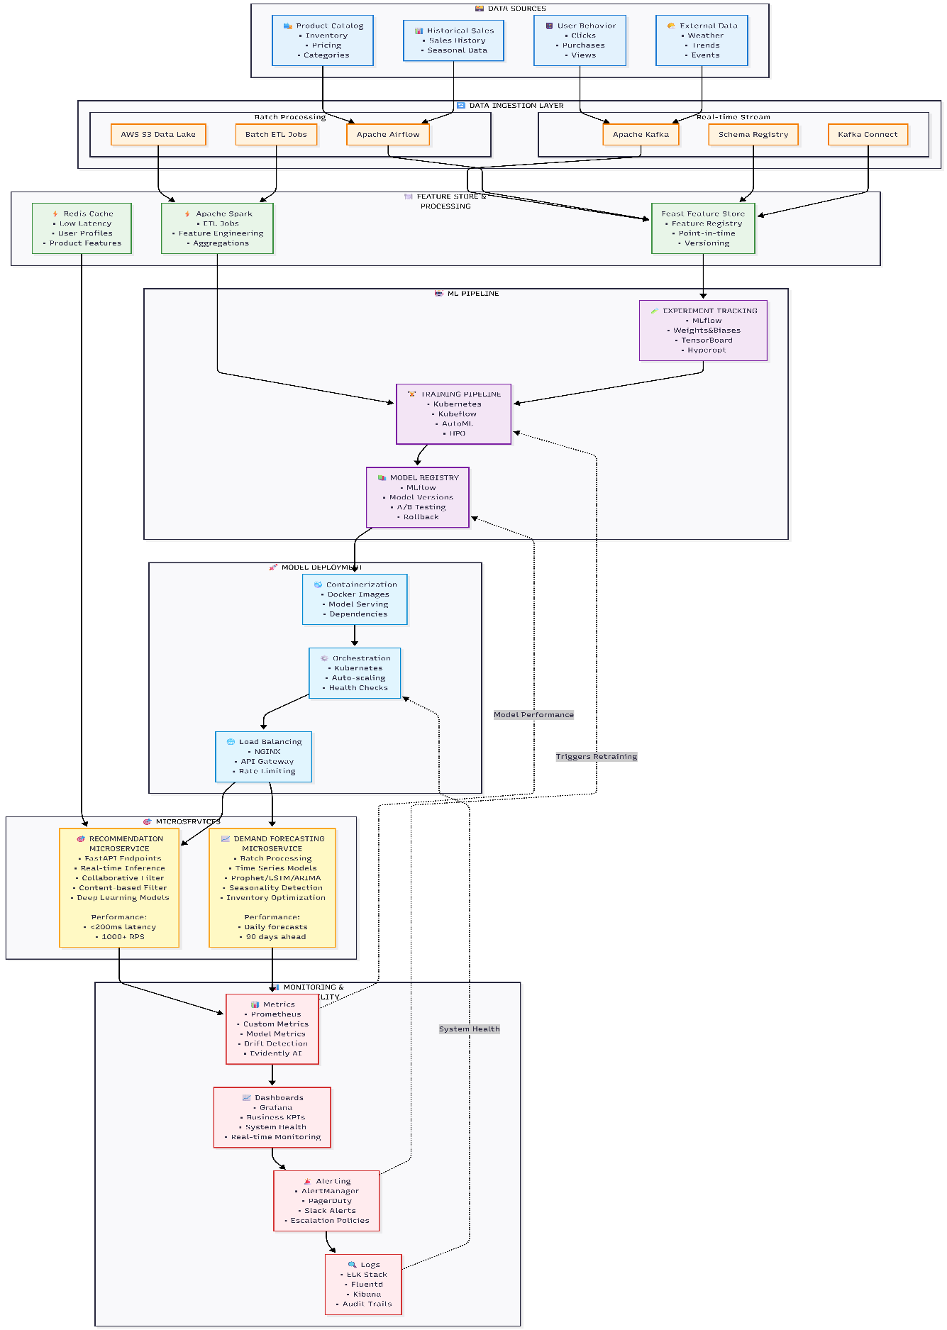
The MLOps system follows a 7-layer architecture:
3.1 DATA SOURCES LAYER
• User interactions, product catalog, external market data, historical sales

3.2 DATA INGESTION LAYER
• Real-time: Apache Kafka for streaming data
• Batch: Apache Airflow for workflow orchestration

3.3 FEATURE STORE AND PROCESSING LAYER
• Feast Feature Store, Apache Spark, Redis Cache

3.4 ML PIPELINE LAYER
• MLflow for experiment tracking and model registry
• Kubernetes for training pipeline orchestration

3.5 MODEL DEPLOYMENT LAYER
• Docker containerization with Kubernetes orchestration

3.6 MICROSERVICES LAYER
• Recommendation service (real-time, <200ms latency)
• Demand forecasting service (batch processing, 90-day forecasts)

3.7 MONITORING AND OBSERVABILITY LAYER
• Prometheus + Grafana for metrics and visualization
• Alerting systems and centralized logging

COMPONENT CONNECTIONS:
• Data flows from sources → Kafka/Airflow → Feature Store → ML Pipeline → Deployment → Microservices
• Monitoring layer observes all components with feedback loops
• Feature Store provides real-time and batch serving capabilities
• Kubernetes orchestrates training, deployment, and scaling across all layers

4. TOOL SELECTION JUSTIFICATION

The architecture employs a carefully selected combination of open-source and managed services to balance flexibility, cost-effectiveness, and operational excellence.

4.1 DATA INFRASTRUCTURE DECISIONS

Apache Kafka (Real-time Streaming):
• Handles millions of user interactions per second
• Built-in fault tolerance ensuring no data loss during peak traffic
• Horizontal scalability for growing user bases
• Alternative considered: Apache Pulsar

Apache Airflow (Workflow Orchestration):
• Python-native design aligning with ML team expertise
• Clear DAG visualization for complex data pipelines
• Built-in retry logic and error handling mechanisms
• Alternatives considered: Prefect, Kubeflow Pipelines

4.2 MACHINE LEARNING PLATFORM DECISIONS

MLflow (Experiment Tracking & Model Registry):
• Open-source nature avoiding vendor lock-in while remaining cost-effective
• Supports multiple programming languages (Python, R, Java, Scala)
• Standardized model packaging and deployment capabilities
• Alternatives considered: Weights & Biases, Neptune

Kubernetes + Docker (Container Orchestration):
• Automatic resource scaling based on demand
• Built-in redundancy and fault tolerance
• Industry standard with largest ecosystem
• Alternatives considered: AWS ECS, Docker Swarm

4.3 FEATURE STORE SELECTION

Feast Feature Store:
• Open-source architecture providing cost-effectiveness and customization
• Supports both real-time and batch serving patterns
• Ensures point-in-time correctness for consistent training data
• Alternatives considered: Tecton, AWS SageMaker Feature Store

4.4 MONITORING AND OBSERVABILITY DECISIONS

Prometheus + Grafana (Metrics & Visualization):
• Industry standard for metrics and visualization
• Pull-based model operating efficiently at scale
• Built-in alerting through Alert Manager
• Alternatives considered: DataDog, New Relic

Evidently AI (ML-specific Monitoring):
• Purpose-built for machine learning model monitoring
• Advanced data and model drift detection capabilities
• Simple API integration for custom implementations
• Alternatives considered: Arize, WhyLabs

4.5 HYBRID APPROACH RATIONALE

Strategic Benefits:
• Core infrastructure uses open-source tools (Kafka, Kubernetes, MLflow) for flexibility
• Managed storage services (AWS RDS, S3) provide reliability and reduced operational overhead
• Monitoring combines open-source solutions with managed alerting services
• Cost optimization through selective use of managed services
• Maintains vendor flexibility for future requirements
• Ensures operational excellence through proven enterprise-grade tools
• Scales effectively with business growth while maintaining technical sophistication

5. SOLUTION WORKFLOW

The workflow outlines the end-to-end process of building and operating the MLOps system for demand forecasting and recommendations.

5.1 DATA AND MODEL EXPERIMENTATION

Tools Used: Jupyter Hub, MLflow, Git, DVC, Feast Feature Store

Workflow Steps:
• Sandbox Environment: Set up isolated experimentation environment using Kubernetes namespaces
• Data Access: Connect to Feature Store (Feast) for standardized data access and exploration
• Experiment Tracking: Configure MLflow tracking server for systematic experiment management
• Model Development: Test collaborative filtering, content-based filtering, and hybrid approaches for recommendations
• Demand Forecasting: Experiment with ARIMA, Prophet, LSTM, and ensemble methods
• Evaluation Criteria: Use Precision@K, Recall@K, NDCG for recommendations; MAPE, RMSE, MAE for forecasting
• Model Comparison: Use MLflow UI for experiment comparison and statistical significance testing

5.2 AUTOMATION OF DATA PIPELINE

Real-time Data Ingestion:
• Apache Kafka: Captures user interaction events (clicks, purchases, cart additions)
• Schema Registry: Ensures data consistency and validation
• Kafka Connect: Seamless integration with various data sources

Batch Data Processing:
• Apache Airflow: Orchestrates daily data workflows with DAG visualization
• Apache Spark: Handles large-scale feature engineering and ETL operations
• AWS S3: Provides centralized data lake storage solution
Feature Engineering Pipeline:
• User Features: Purchase history, browsing patterns, demographics, seasonality preferences
• Product Features: Category, price range, popularity scores, seasonal trends
• Contextual Features: Time of day, weather, ongoing promotions
• Quality Assurance: Data validation using Great Expectations and automated alerts

5.3 AUTOMATION OF TRAINING PIPELINE

Tools Used: Kubeflow Pipelines, MLflow, Kubernetes, Optuna

Training Pipeline Steps:
• Data Validation: Automated data quality checks before training
• Feature Engineering: Standardized feature preparation and selection
• Model Training: Distributed training using Kubernetes and Kubeflow
• Hyperparameter Optimization: Automated tuning using Optuna integrated with MLflow
• Model Validation: Cross-validation, business logic testing, and A/B testing framework
• Performance Benchmarking: Latency and throughput testing
• Model Registration: Centralized model versioning in MLflow registry
• Automated Deployment: Blue-green and canary deployment strategies with automated rollback

5.4 AUTOMATION OF INFERENCE PIPELINE

Real-time Recommendation Serving:
• FastAPI: RESTful API endpoints for recommendation requests
• Redis Cache: Low-latency access to user profiles and popular items
• NGINX Load Balancer: High availability and traffic distribution
• Kubernetes HPA: Auto-scaling based on CPU/memory usage
• Performance Target: <200ms latency, 1000+ requests per second

Batch Demand Forecasting:
• Daily Processing: Automated forecasting pipeline running at 2 AM daily
• Time Series Models: Prophet, LSTM, ARIMA for different product categories
• Seasonality Detection: Automatic identification of seasonal patterns
• Inventory Integration: Direct updates to inventory management system
• Forecast Horizon: 90-day ahead predictions with daily updates

5.5 CONTINUOUS MONITORING PIPELINE

Performance Monitoring:
• Prometheus: Metrics collection for API latency, throughput, error rates
• Grafana: Real-time dashboards for business KPIs and system health
• Custom Metrics: Model accuracy, conversion rates, recommendation relevance

Data and Model Drift Detection:
• Evidently AI: Statistical tests for data distribution changes
• Automated Alerts: Slack/email notifications when drift thresholds exceeded
• Feature-level Analysis: Identification of specific drifting features
• Performance Tracking: Continuous monitoring of model accuracy trends

Business Impact Monitoring:
• Real-time KPI Tracking: CTR, conversion rate, revenue attribution
• A/B Testing Framework: Continuous model performance comparison
• Alert Categories: Critical (immediate response), Warning (1-hour response), Info (notification only)

6. SPECIAL SCENARIOS

6.1 DRIFT DETECTION HANDLING

Drift Detection Components:
• Evidently AI: Statistical drift detection using KL-divergence and Kolmogorov-Smirnov tests
• Threshold Setting: Configurable drift thresholds based on business impact
• Feature-level Monitoring: Individual feature drift tracking and analysis
• Automated Logging: Complete drift detection event recording

When Drift is Detected (Below Threshold):
• Warning Logs: Record drift detection event with severity level
• Enhanced Monitoring: Increase data collection frequency and analysis depth
• Feature Analysis: Identify specific features contributing to drift
• Stakeholder Notification: Alert data science team via Slack/email integration

When Drift Exceeds Threshold:
• Immediate Actions: Trigger automated model performance evaluation
• Root Cause Analysis: Analyze drift patterns and identify potential causes
• Model Rollback: Automatic reversion to previous stable model version
• Fallback Strategies: Activate rule-based recommendation system as backup
• Emergency Response: Page on-call engineering team for immediate intervention

Automated Response Workflow:
• Performance Check: Validate current model accuracy against baseline
• Data Pipeline Audit: Verify data source integrity and processing pipeline
• Model Retraining: Trigger automated retraining with recent data
• Stakeholder Communication: Send detailed drift analysis reports
• Recovery Monitoring: Track system recovery and performance restoration

6.2 NEW ANNOTATED DATA HANDLING

Data Ingestion Triggers:
• User Feedback: Thumbs up/down on recommendations, rating systems
• Purchase Confirmations: Implicit positive feedback from completed purchases
• Customer Service: Interaction logs and review sentiment analysis
• A/B Test Results: Labeled outcomes from controlled experiments
Automated Processing Pipeline:
• Data Validation: Quality checks for new annotation consistency
• Volume Assessment: Determine if data volume justifies retraining
• Performance Impact: Evaluate potential improvement from new annotations
• Training Strategy Selection: Choose between full retraining vs incremental learning
Incremental Learning Strategy:
• Online Learning: Real-time model updates for recommendation engines
• Batch Updates: Weekly full retraining for demand forecasting models
• Hybrid Approach: Combine online updates with periodic full retraining
• Performance Monitoring: Track improvement metrics after incorporating new data
Quality Assurance for Annotations:
• Consistency Checks: Validate annotation quality and remove outliers
• Bias Detection: Monitor for annotation bias and data imbalance
• Ground Truth Validation: Cross-reference with historical performance data
• Feedback Loop: Incorporate annotation quality metrics into model training
Automated Retraining Triggers:
• Volume Threshold: Retrain when annotation count exceeds defined threshold
• Performance Degradation: Trigger retraining when accuracy drops below target
• Time-based Schedule: Regular retraining cycles regardless of data volume
• Business Events: Retrain after major product launches or seasonal changes
Decision Matrix for Retraining:
• Immediate Retraining: High-value annotations, significant performance drop
• Scheduled Retraining: Moderate annotation volume, stable performance
• Hold and Monitor: Low annotation volume, acceptable current performance
• Emergency Retraining: Critical system issues, major data distribution changes

